**Math 120  
3.5 Rational Functions and Their Graphs**

# **Objectives:**

1. Find the domain of rational functions.
2. Identify vertical asymptotes.
3. Identify horizontal asymptotes.
4. Graph rational functions.
5. Solve applied problems involving rational functions.

# **Topic #1: Rational Functions and Domain**

A rational function is the RATIO of two polynomial functions and ; by definition:



Since rational functions involve division, values of that make the denominator __________________are EXCLUDED from the domain.



Consider the base rational/reciprocal function:

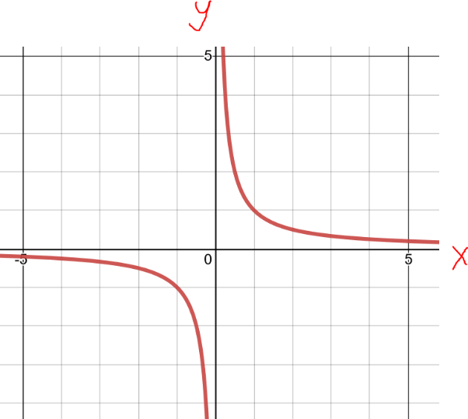The function has division and the domain in set notation is ____________________



A graph shows there is a break where ________________ creating two branches.



*Example #1* – Find the Domain of the Rational Function



Set the factors in the denominator to zero, the domain is all real numbers except



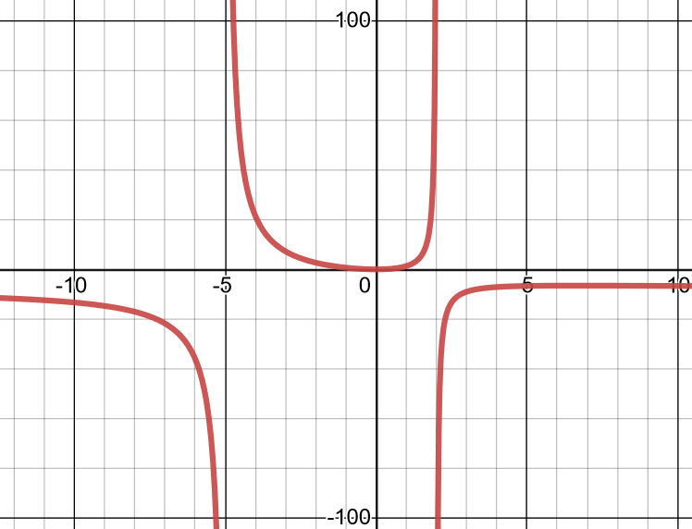

In interval notation AND Set notation this is:



A graph shows breaks at x=-5 and x=2:

The denominator can be set to zero and solved several ways. One way is to factor the denominator



and use the zero product property, showing the domain is all real numbers except



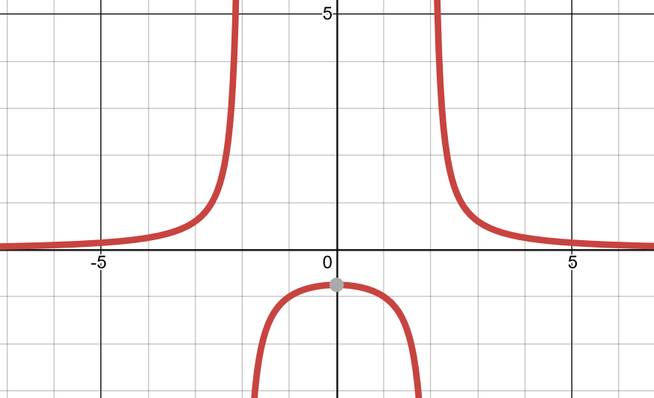In interval notation AND Set notation this is:



A graph shows the breaks at these points along the -axis:

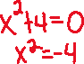

Set the denominator to zero and solve:



Since the zeros are complex, there are no real number breaks along the x-axis and the domain is________________



A graph shows that there are NO breaks along the -axis:



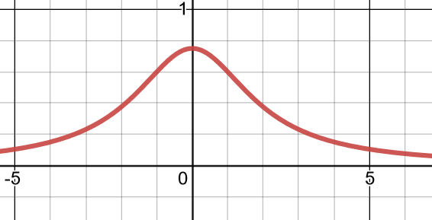



The denominator factors to:



Setting the factors to zero gives the domain

In interval notation AND Set notation this is:



Depending on your calculator, the graph may only show one break along the -axis however (when :

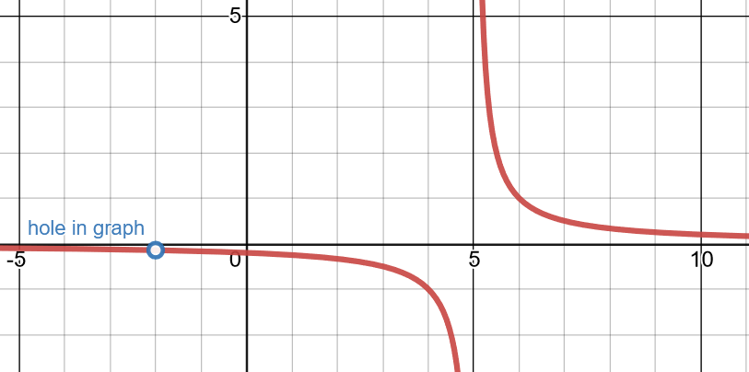



The domain was correctly identified, but when there is a hole in the graph.

That is because the factor in the denominator is canceled/removed by the common factor in the numerator!



# **Topic #2: Rational Functions and Vertical Asymptotes**

A **________________________**occurs along the -axis **where there is a ____________________ in the denominator that cannot be canceled/removed.**



The graph of the functions gets “vertical” at that point along the -axis. Consider the graph of the base reciprocal function:

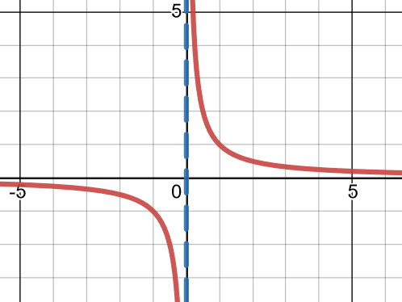



Notice that the graph becomes “vertical” on either side of . This is where “branches” are created on either side of a **vertical asymptote at x=0**.



**The graph approaches but *never crosses* this line at _______________**



*Example #1* – Find the Vertical Asymptotes of the Rational Function

Set the factor in the denominator ________________ , the domain is all real numbers except:



Since the factor cannot be canceled/removed (no common factors in both numerator and denominator), there is a vertical asymptote at:



A graph shows the curve getting vertical and branches created:

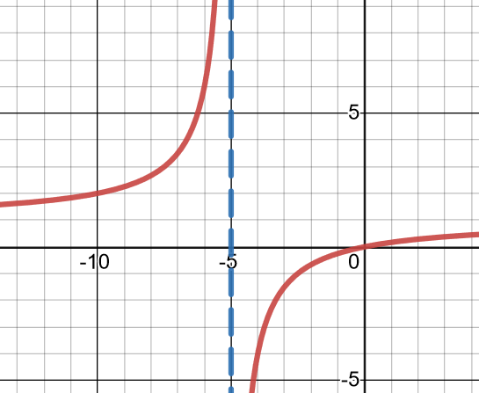

Notice as approaches the asymptote from the left, the curve gets vertical in the positive direction. Notice as approaches the asymptote from the right, the curve gets vertical in the negative direction.

The denominator can be set ____________ and solved several ways. One way to do this is to factor and use the zero-product property:



Since the factors cannot be canceled/removed (no common factors in both numerator and denominator), there are vertical asymptotes at:



A graph shows the curve getting vertical twice and graph has three separate branches:

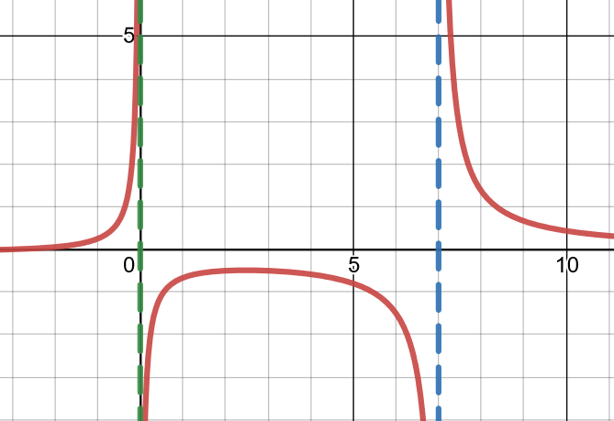

Set the denominator to zero and solve

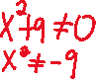

Since the zeros are complex, the domain is _______________



As a result, there are _______________ vertical asymptotes.



A graph shows that the curve NEVER gets vertical:

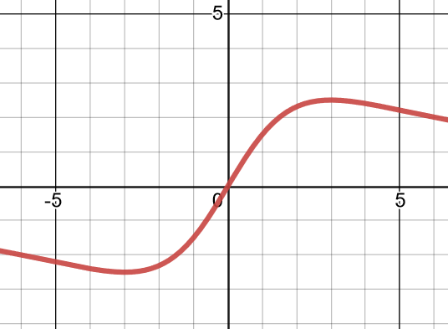



The denominator factors to:

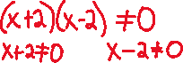

Setting factors equal to zero gives the domain _________



However, there is only one vertical asymptote at _______



The factor in the denominator is canceled/removed by the common factor in the numerator, creating a hole at :

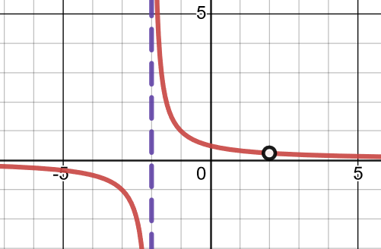

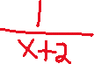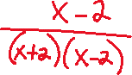

# **Topic #3: Rational Functions and Horizontal Asymptotes**

A horizontal asymptote describes the “end behavior” of certain rational functions. In these cases, when gets very large ____________________OR gets very small ________________ the curve “flattens” to a limiting value. There are 2 cases where a horizontal asymptote occurs in a rational function.



***Case One: Dominant Term in the Denominator is a Higher Degree than Dominant Term in Numerator***



Consider the graph of the base reciprocal function:

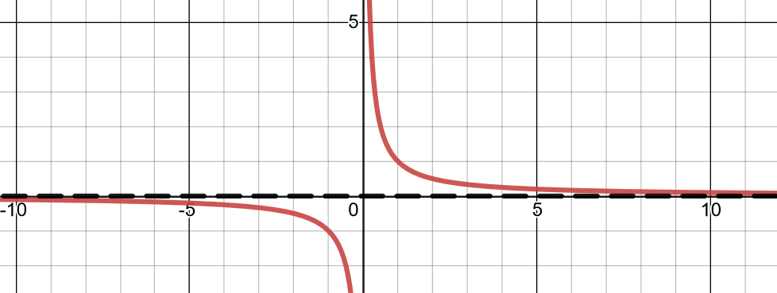

Notice that when goes further to the right, the curve flattens to LIMITING VALUE OF _______________ Also, when goes further to the left, the curve flattens to A LIMITING VALUE OF ________________



This shows there is a horizontal asymptote at . Also notice the higher power is in the________________.



**Whenever the dominant term in the denominator is a ____________________________________, there is a horizontal asymptote at .**



***Case Two: Dominant Term Denominator is the Same Degree as Dominant Term in Numerator***



Consider the function:

; x≠3

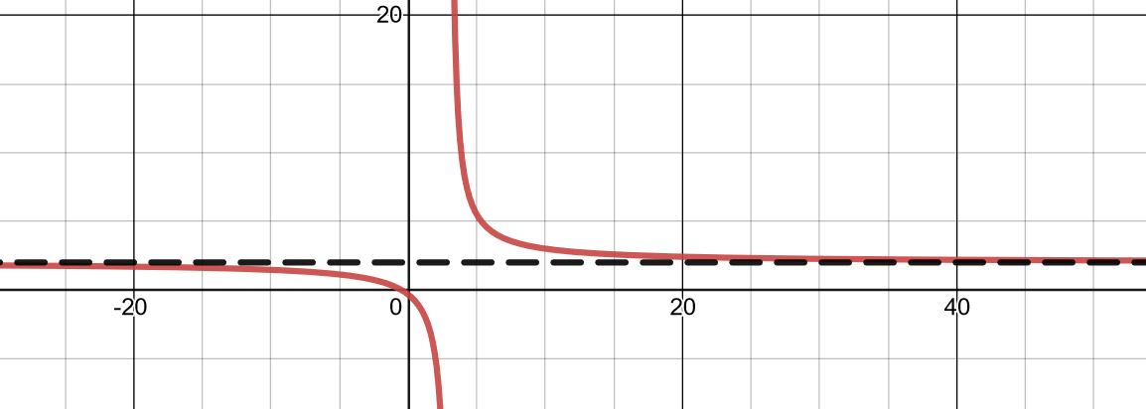

The dominant term in the numerator is _________



and the dominant term in the denominator is



Both terms are of the same degree/power. Notice the horizontal asymptote here is .



**Whenever the dominant terms in numerator and denominator are of the _____________________ there is a horizontal asymptote that is the ______________________________________________**



*Example #1* – Find the Horizontal Asymptotes of the Rational Function

The dominant terms in the numerator and denominator are _____________________________



Therefore the horizontal asymptote ______________________________________________



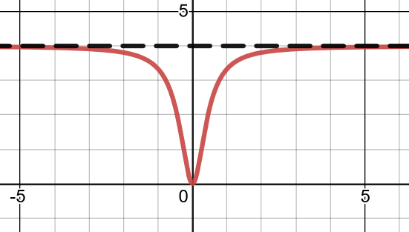



The dominant term in the denominator is______________________



the horizontal asymptote is______________________



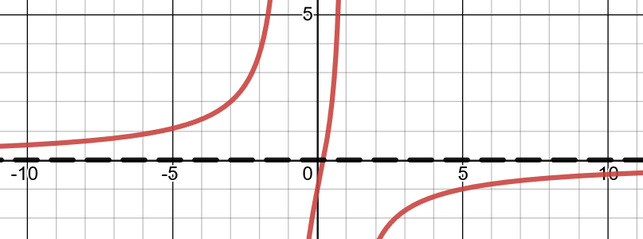



The dominant term in the **numerator** is of a **___________________** than the dominant term in the **denominator**;



**when this is the case** **there is _____________________**



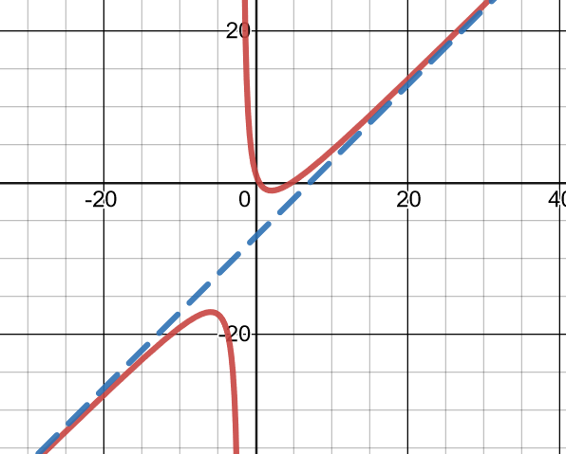



# **Topic #4: Applications of Rational Functions**

*Example #1* – Analyze a Rational Model

The pH level, , of the human mouth minutes after a person eats food containing sugar is modeled by the function:

Let x be:



Let f(x) be:



A graph of the function follows:

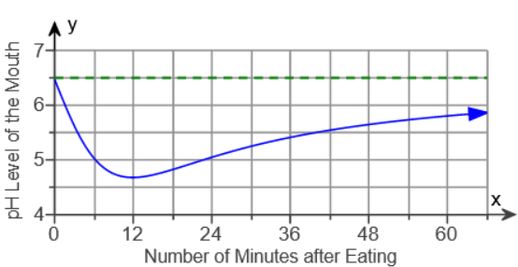

a) What is the pH level 36 minutes after the person eats the food? Round to nearest tenth.

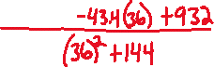

b) When does the pH level reach the lowest level? What is the level?

The graph has a minimum when , so the pH reaches its lowest level **12 minutes** after the person eats the food. Looking at the graph, the pH level at that time is



c) Find the equation of the horizontal asymptote and interpret its meaning.

The dominant term in the numerator is ______________________ as the denominator, so the equation of the horizontal asymptote is the ratio of the leading coefficients:



What does this tell us?



d) Reference the graph to write a sentence describing what happens to the pH level during the first hour after the person eats the food.



*Example #2* – Analyze a Rational Model

A drug is injected into a patient and the concentration of the drug in the bloodstream is monitored. The drugs concentration, , in milligrams per liter, after hours is modeled by the function:



Let t be:



Let C(t) be:



A graph of the function follows:

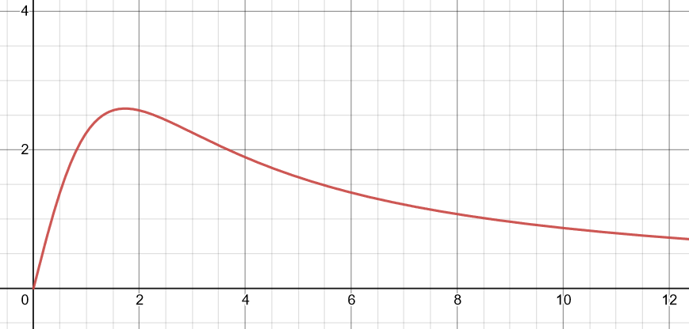



a) What is the concentration of the drug in the bloodstream after hours? Round to the nearest tenth and include units.

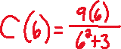

b) At what time(s) will the concentration of the drug in the bloodstream be milligram per liter? Round to the nearest tenth hour.



This tells us to find when



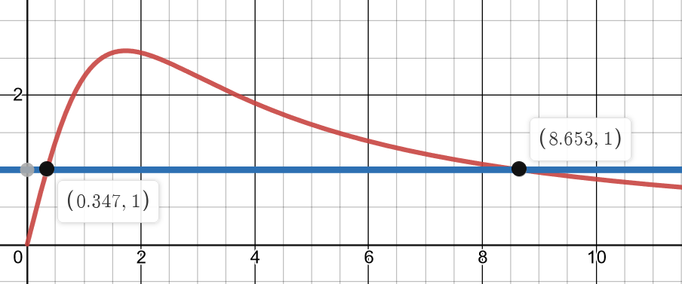

c) Find the equation of the horizontal asymptote and interpret its meaning.

The dominant term in the denominator is ________________than the numerator, so the equation of the horizontal asymptote is _________. This tells us:

